Batch: B2 Roll No.: 16010121200

Experiment No. 10

Grade: AA / AB / BB / BC / CC / CD /DD

Signature of the Staff In-charge with date

Title: Case study on Fuzzy Inference System
___________________________________________________________________________
Aim:
To apply fuzzy logic and determine the time required to run a washing machine, given the amount of dirt and grease on clothes.
___________________________________________________________________________
Theory:
Architecture of fuzzy logic control:
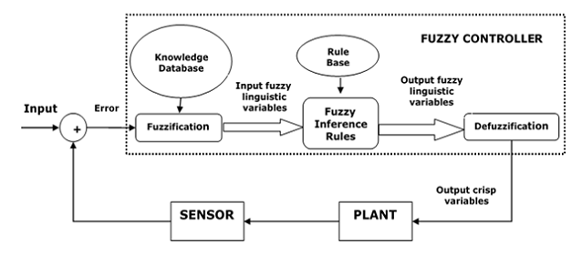

Major Components of FLC
Followings are the major components of the FLC as shown in the above figure −
- Fuzzifier − the role of fuzzifier is to convert the crisp input values into fuzzy values.
- Fuzzy Knowledge Base − It stores the knowledge about all the input-output fuzzy relationships. It also has the membership function which defines the input variables to the fuzzy rule base and the output variables to the plant under control.
- Fuzzy Rule Base − It stores the knowledge about the operation of the process of domain.
- Inference Engine − It acts as a kernel of any FLC. Basically it simulates human decisions by performing approximate reasoning.
- Defuzzifier − The role of defuzzifier is to convert the fuzzy values into crisp values getting from fuzzy inference engine

Steps in Designing FLC
Following are the steps involved in designing FLC −
- Identification of variables − Here, the input, output and state variables must be identified of the plant which is under consideration.
- Fuzzy subset configuration − the universe of information is divided into number of fuzzy subsets and each subset is assigned a linguistic label. Always make sure that these fuzzy subsets include all the elements of universe.
- Obtaining membership function − Now obtain the membership function for each fuzzy subset that we get in the above step.
- Fuzzy rule base configuration − Now formulate the fuzzy rule base by assigning relationship between fuzzy input and output.
- Fuzzification − the fuzzification process is initiated in this step.
- Combining fuzzy outputs − by applying fuzzy approximate reasoning, locate the fuzzy output and merge them.
- Defuzzification − finally, initiate defuzzification process to form a crisp output.

Problem:
Design a controller to determine the wash time of a domestic washing machine. Assume the input is dirt and grease on cloths. Use 3 descriptors for input variables and five descriptors for output variables. Derive the set of rules for controller action and defuzzification. The design should be supported by figures wherever possible. Show that the cloths are soiled to larger degree the wash time will be more and vice-versa.
(Assume the inputs dirt and grease are measured in percentage and wash time in minutes).
Evaluate the rule for dirt=60% and grease=70% using appropriate deffuzzification method.

Solution:
Defining Input and Output Variables

Input Variables:
- Dirt Level – Low, Medium, High
- Grease Level – Low, Medium, High

Output Variable:
- Wash Time – Very Short, Short, Medium, Long, Very Long

Defining Membership function:
Dirt (Input Variable):
  - Low: Triangular (0, 0, 40)
  - Medium: Triangular (20, 50, 80)
  - High: Triangular (60, 100, 100)
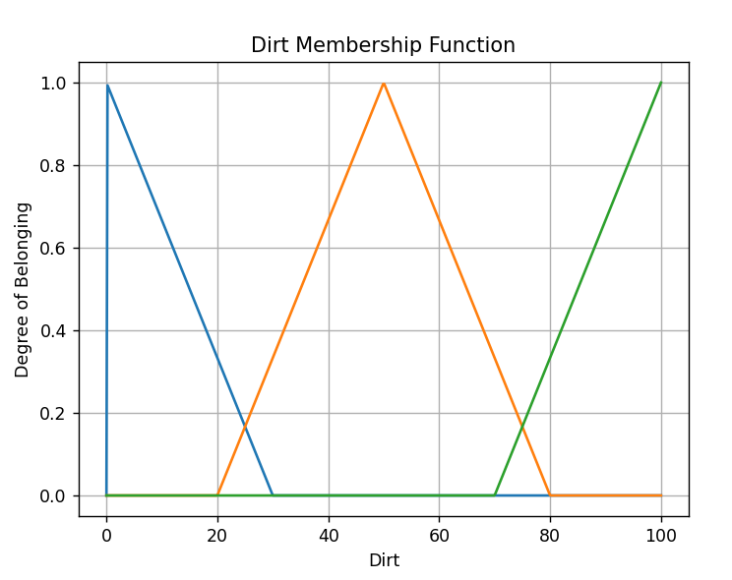

Grease (Input Variable):
  - Low: Triangular (0, 0, 40)
  - Medium: Triangular (20, 50, 80)
  - High: Triangular (60, 100, 100)
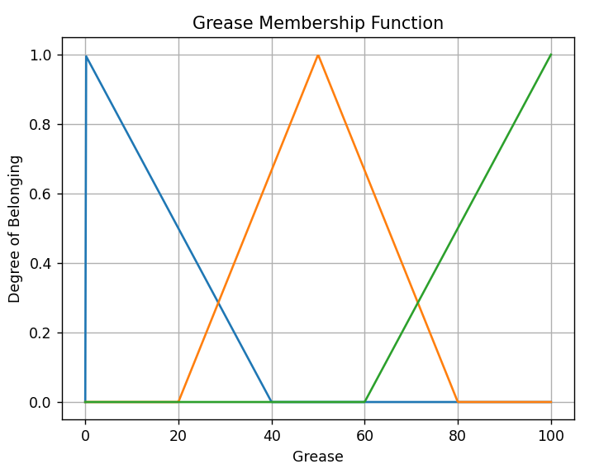

Wash Time (Output Variable):
  - Very Short: Triangular (0, 0, 15)
  - Short: Triangular (10, 20, 30)
  - Medium: Triangular (25, 40, 55)
  - Long: Triangular (50, 70, 90)
  - Very Long: Triangular (85, 100, 100)
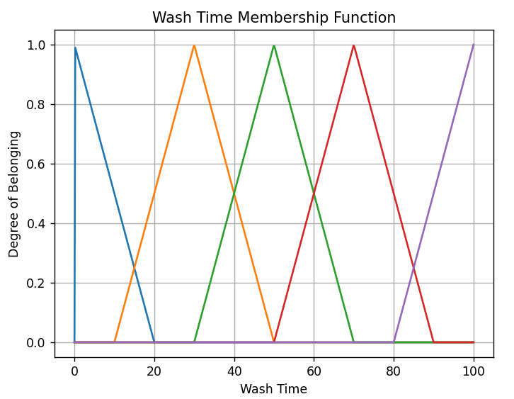

Code:
import numpy as np
import matplotlib.pyplot as plt

# Triangular membership functions for each term
# TRIANGULAR membership function
def triangular_member(x, a, b, c):
"""Triangular membership function"""
if x <= a:
return 0.0
elif a < x <= b:
return (x - a) / (b - a)
elif b < x <= c:
return (c - x) / (c - b)
else:
return 0.0

def createPlot(a_values, b_values, c_values, title):
"""Create plots for each triangular membership function"""
x_values = np.linspace(0, 100, 500)
for a, b, c in zip(a_values, b_values, c_values):
y_values = [triangular_member(x, a, b, c) for x in x_values]
plt.plot(x_values, y_values, label=f'({a}, {b}, {c})')

plt.xlabel(title)
plt.ylabel('Degree of Belonging')
title = title + ' Membership Function'
plt.title(title)
plt.grid()
plt.show()

# Define parameters - Dirt
a_values = [0, 20, 70]
b_values = [0, 50, 100]
c_values = [30, 80, 100]
createPlot(a_values, b_values, c_values, 'Dirt')

# Define parameters - Grease
a_values = [0, 20, 60]
b_values = [0, 50, 100]
c_values = [40, 80, 100]
createPlot(a_values, b_values, c_values, 'Grease')

# Define parameters - Wash Time
a_values = [0, 10, 20, 50, 80]
b_values = [0, 30, 40, 70, 100]
c_values = [20, 50, 60, 90, 100]
createPlot(a_values, b_values, c_values, 'Wash Time')

Defining Fuzzy Rules
Dirt ⬇️/Grease ➡️ | Low | Medium | High
Low | Very Short | Short | Medium
Medium | Short | Medium | Long
High | Medium | Long | Very Long

Defuzzification:
Given:
- Dirt level = 60
- Grease level = 70
Obtain Fuzzy Output:
Calculating membership of each input:
Code:
# Input: Dirt = 60, Grease = 70
input_value = 60
parameters_d = list(zip(a_values_d, b_values_d, c_values_d))
print("Dirt:")
print("Low\tMedium\tHigh")
for a, b, c in parameters_d:
result = round(triangular_member(input_value, a, b, c), 3)
print(result, end = "\t")
print()

input_value = 70
parameters_g = list(zip(a_values_g, b_values_g, c_values_g))
print("Grease:")
print("Low\tMedium\tHigh")
for a, b, c in parameters_d:
result = round(triangular_member(input_value, a, b, c), 3)
print(result, end = "\t")
print()
Output:
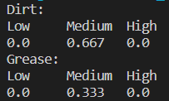
Fuzzy output:
Dirt is medium, grease is medium Washing time is medium
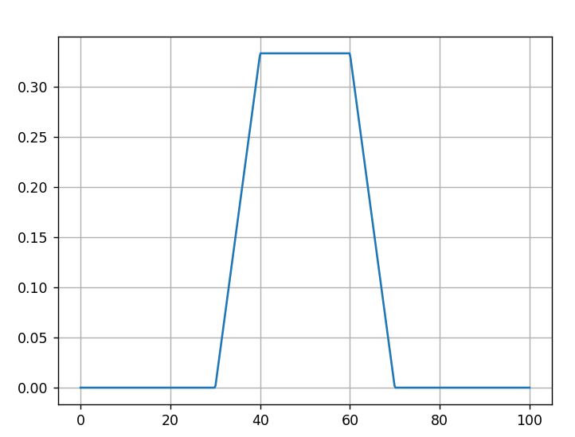
Calculating crisp value from fuzzy output
Method used: Mean of maxima
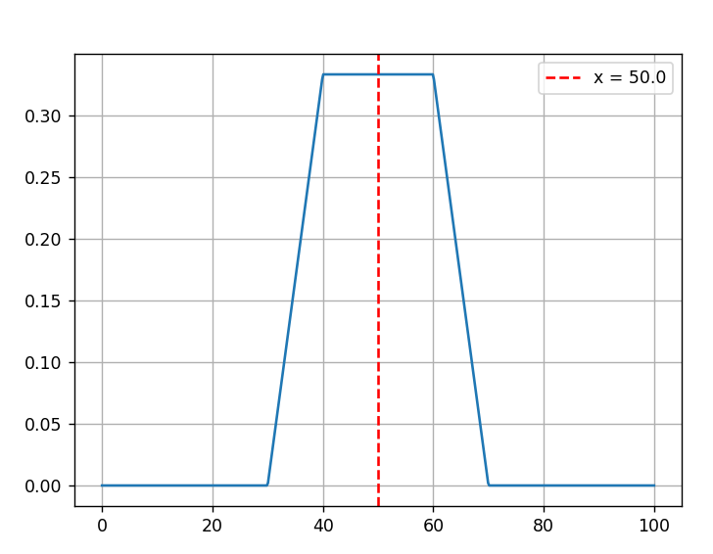
Thus, 50 minutes of washing time is required when dirt is 60% and grease is 70%.
References:
https://www.geeksforgeeks.org/fuzzy-logic-control-system/
https://www.tutorialspoint.com/fuzzy_logic/fuzzy_logic_inference_system.htm
https://arxiv.org/ftp/arxiv/papers/1701/1701.01654.pdf
Summary:
Fuzzy Logic Controllers in washing machines use a flexible and adaptive approach to optimize the washing process. They consider factors such as weight of clothes, grease on clothes, and/or detergent amount to adjust water levels, temperature, and cycle duration, resulting in efficient and effective cleaning while conserving resources like water and energy.
Additionally, they enhance user convenience by offering predefined washing presets and error handling, making washing machines more intelligent and user-friendly appliances.

Post Lab Question:
- Explain applications of fuzzy logic in image processing.

Image Enhancement:
Fuzzy logic can be used to enhance the quality of digital images by adjusting parameters like brightness, contrast, and sharpness. Instead of using rigid, binary rules, fuzzy systems allow for gradual adjustments, making it suitable for handling imprecise or unclear image data.

Image Segmentation:
Fuzzy logic can help in image segmentation, which involves dividing an image into meaningful regions. Fuzzy clustering algorithms, such as Fuzzy C-Means (FCM), allow pixels to belong to multiple clusters with different degrees of membership, which is particularly useful when boundaries between objects in the image are not well-defined.

Edge Detection:
Fuzzy logic can be applied to edge detection algorithms to identify edges in images. Fuzzy edge detection methods can handle gradual intensity transitions and are less sensitive to noise compared to traditional edge detection techniques.

Object Recognition:
Fuzzy logic can be used in object recognition tasks where an image may contain partially occluded or deformed objects. Fuzzy rules can accommodate uncertainty in object appearance and deformation.

Color Image Processing:
Fuzzy logic is useful in handling color information in images. Fuzzy color space transformations and color correction algorithms can be used to adjust colors in images based on linguistic descriptions (e.g., "make the image more vibrant").

